The Optimal State

Software Requirement Specification (SRS)



Fall 2024

Dr. Lo’ai Tawalbeh

Version 1.0

Mohammad Nawasra (PM)

Hussam Sayaheen (Software Engineer)

Rashed Alshboul (UI/UX Designer)

Ahmad Alkoshah (Quality Assurance and Documentation)

Table of Contents

1. Introduction……………………………………………………………………………………. 3
   1. Purpose……………………………………………………………………………….. 3
   2. Scope……………………………………………………………..……………………3
   3. Definitions, Acronyms, and Abbreviations……………………………………….....3-4
   4. References……………………………………………………………………………..4
   5. Overview……………………………………………………………………………....4
2. Overall Description……………………………………………………………………………..5
   1. Product Perspectives…………………………………………………………………..5
      1. System interfaces (deployment diagram)........................................................5
      2. User interfaces……………………………………………………………5-6
      3. Software interfaces……………………………………………………….….6
      4. Communication interfaces…………………………………………………..6
      5. Memory……………………………………………………………………...6
      6. Operation………………………………………………………………….....6
   2. Product Functions (use case diagram)............................................................................7
   3. User Characteristics…………………………………………………………………...7
   4. Constraints…………………………………………………………………………….7
   5. Assumptions and Dependencies……………………………………………………....8
3. Specific Requirements……………………………………………………………………….....8
   1. External interface requirements…………………………………………………….....8
      1. User interfaces……………………………………………………………....8
      2. Hardware interfaces………………………………………………………....8 3.1.3 Software interfaces………………………………………………….....8

3.1.4 Communication interfaces……………………………………………….….8

* 1. Functional requirements…………………………………………………………...8-19
  2. Performance requirements…………………………………………………………...19
  3. Design constraints…………………………………………………………………....19
  4. Software system attributes…………………………………………………………...20
     1. Reliability…………………………………………………………………..20
     2. Maintainability……………………………………………………………..20
     3. Portability…………………………………………………………………..20

# 1. Introduction

## 1.1. Purpose

This Software Requirement Specification is designed to outline the requirements and goals of the Optimal State Application. Requirements listed in this document reflect those discussed with clients Amy Wheeler and George. These

requirements are expected to be implemented and tested by the end of the Spring 2018 quarter for the CSE-455 Software Engineering Course

**1.2. Scope**

The Optimal State Application will enable users to not only monitor and track their state of mind, but will also provide the user with a multitude of exercises, techniques and other information to better their current state. The main elements of this are the Android Application, and Clients website in order to access other information.

Prototype 1: The first prototype will consist of an application which will allow users to login in or create a new user profile, a functionable general user homepage, functionable assessment interface, functional exercises interface.

Prototype 2: The second prototype will consist of the application which will allow users to view their mental status history, a provider main interface, a functionable add/remove client interface, and a functional view client history interface.

## 1.3 Definitions, Acronyms, and Abbreviation​s

**Android**​: Mobile operating system running on the user’s device.

**Android SDK**​: A SDK (Software Development Kit) is a set of development tools used to develop applications for android platform.

**IDE:** ​Integrated Development Environment, used by programmers to test and develop code in a specific language pr for a device.

**Android Studio**​: An IDE (Integrated Development Environment) used for developing applications for the android operating system.

**App**​: A type of software that allows the user to perform specific tasks.

**Deployment diagram**​: A structure diagram which shows the architecture of the system as deployment (distribution) of software artifacts to deployment targets.

**Emoji**​: A small digital image or icon used to express an idea, emotion, etc., in electronic communication.

**Firebase Web Server**​: Web based server provided by google which allows for access to web services and database

**Firebase Database**​: Location were all user data is stored and accessed during use of the application

**Home screen**:​ The introductory interface displayed on the device, from which a user is able to access particular functions.

**Java**​: A general purpose object-oriented computer-programming language. **Mental health**​: A person's condition with regard to their psychological and emotional well-being.

**Mobile device**​: A portable computing device such as a smartphone or tablet computer. **Programming Language**​: A vocabulary and set of grammatical rules for instructing a computer or computing device to perform specific tasks.

**SRS**​: This document, The software requirements specification (SRS) document lays out the functional and non-functional requirements of the Optimal State App.

**UML**​: Unified Modeling Language (UML) is a standardized modeling language enabling developers to specify, visualize, construct and document artifacts of a software system. **Use case diagram**​: A representation of a user’s interaction with the system that shows the relationship between the user and the different use cases in which the user is involved. **User**​: Someone who uses the application or software specified in this software requirements specification.

**Home-page**​: The primary page of the application.

**Providers:** ​A health-care professional which includes: general doctor, psychiatrist, counselor, or any professional whose purpose is to aid patients in improving their well-being.

## 1.4 References

[1] IEEE Software Engineering Standard Committee, “IEEE Std 830-1998, IEEE Recommended Practice for Software Requirements Specifications”, October 20, 1998.

[2] Fowler, Martin. ​*UML Distilled: A brief guide to the standard object modeling language - third edition*​. Pearson Education, Inc. 25 September, 2003.

## 1.5 Overview

The following information provided in this document is intended to provide further details about the application as well as provide the details of the use, functionality and plans for the Optimal State application.

The second section of this document provides the user with and overview of the application and how it works. It describes how the software systems are integrated and their constraints.

The third section of this document specifies the requirements of the project. It demonstrates specific components, iterations of software interfaces, design constraints, and system requirements.

# 2. Overall Description

## 2.1 Product Perspectives

### 2.1.1 System interface (deployment diagram)

**Ps: Sign out option is added to the user/provider interface,Useerdata is only in real time database.**

There are 3 major components involved in this project: the Firebase web server which contains interfaces for management, the firebase database which provides real-time database and the android device itself.

### 2.1.2 User interfaces: Individual User

Upon opening the Optimal State application, the user will be taken to a user login screen. If the user is already logged in, they will automatically be taken to the user home screen. The home screen displays the companies logo with a variety of options for the user include, take assessment, view excersise, view history settings and sign out. The assessment screen displays a version of the company logo with four clickable regions. Once user finishes there assessment they will go back and then press the view exercises interface where they will be given information to improve their mental state. The view history option will allow for users to track and monitor there mental state over a period of time. The settings interface will allow for user’s to change there personal info, notification times, show information and the option to delete the users account.

# Provider

Similar to the Individual User interface, the provider will go through the same routine. At the provider home interface, they will be provided options of add/removing clients, viewing clients history and other settings. The add/remove interface will allow providers to add clients to a list or remove them from said list. The view history interface will list all of there current patients, additional information for patients will be provided . The settings interface will be similar to the individual user interface minus the set notifications option.

## 2.1.3 Software interfaces

There are two major software interfaces used in this project

1. **Android Studio**​ is used to work on the mobile application for Android Devices
2. **Firebase Server**​ is used to handle HTTP requests sent by Android Devices.

The Firebase Server runs on a Occupancy Web Server which includes two interfaces

* 1. **Authentication**​ - which stores user emails and assigns them a UID
  2. **Database**​ - web based database which stores and organizes user information.

## 2.1.4 Communication interfaces

The only communication interface is between the mobile device and the Firebase Server. The mobile device establishes an HTTP connection with the Firebase Web Server which can be relayed back to the mobile device..

## 2.1.5 Memory

The Firebase Server is limited to 1GB of storage and 10 GB downloads with 100 simultaneous connections. This is due to using the free serves that Firebase provides. If app is completed clients may view serves plans for larger storage capacity. The mobile app should be limited to 32 MB share of memory.

## 2.1.6 Operation

The Firebase Web Server will need to be active during all activity of the mobile app. As Firebase is provided by google Inc., there servers run 24/7 and provide adequate protection of data.

## 2.2 Product Functions (use case diagram)

The application allows users to track their mental state, while attempting to provide solutions for them to improve their current state. The provider side of the application allows for providers to view the current mental state of their patients which will help them in their evaluations, and provide them with knowledge which could help aid their patients.

## 2.3 User Characteristics

The Use-Case Diagram shows that the personal user will be able to take assessments, view exercises to improve their mental state, review their past history, and change personal settings. The provider user will be able to add/remove patients, view their patients history, and edit personal settings. The intended demographic using the Optimal State application encompasses all individuals who would like to monitor or improve their person mental state. The application does, however, allows for providers to monitor patients which reduce the need for making routine appointments.

## 2.4 Constraints

1. Learning unfamiliar technologies such as Server, databases, and Android Studio.
2. Becoming familiar with Firebase and all its features
3. Setting up a Server and database in a timely manner.

4. Learning how to properly design and develop and application, in a professional setting

## 2.5 Assumptions and Dependencies

1. The Android Device has internet access
2. Firebase features such as database and server will be functional at all times

# 3.​ Specific Requirements

## 3.1 External interface requirements

### 3.1.1 User interfaces

The user interface consists of graphical elements in the Android App. More information of the apps interface is found in Section 3.2

**3.1.2 Hardware interfaces**

There are no external hardware interfaces for this project

### 3.1.3 Software interfaces

The Optimal State app communicates with the Firebase Web Server to retrieve and save information for the user, using Firebase Database. The application also communicates with the Firebase Web Server to request web page information from the client's web-site amywheeler.com for further content and data.

### 3.1.4 Communication interfaces

The Firebase Web Server must communicate with mobile device in order to send and retrieve user’s information on the Android device.

## 3.2 Functional requirements and User Interfaces

If a user is not already logged into the application, the login interface will be first to load(Figure 1)

(Figure 1: Login Screen)

If a user does not have an account they may click the create here button which will take them to the create account interface.(Figure 2)

**(**​Figure 2: Create Account Screen)

If a general user is logged in already they will be taken to the general user interface which provides four options for the user to continue with. (Figure 3)

(Figure 3: Home Screen)

The assessment page will allow users to take an assessment which describes their current mental state. Upon completion they will go back and then go to the Exercise interface. (Figure 4)

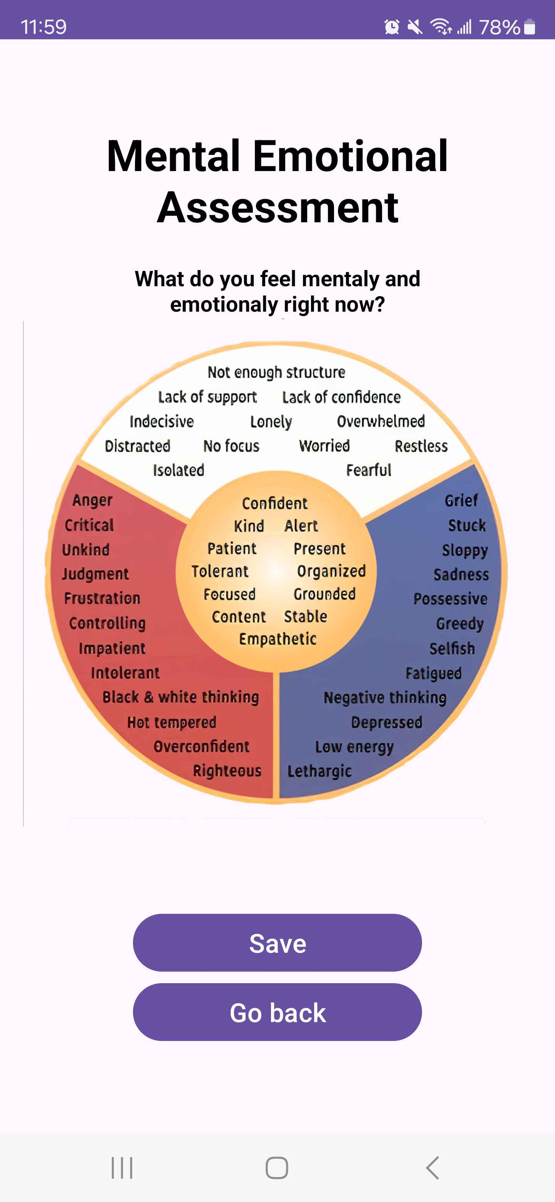

(Figure 4: Assessment Screen)

At the exercise interface, the user will be able to see information on how to improve there last recorded mental state.(Figure 5)

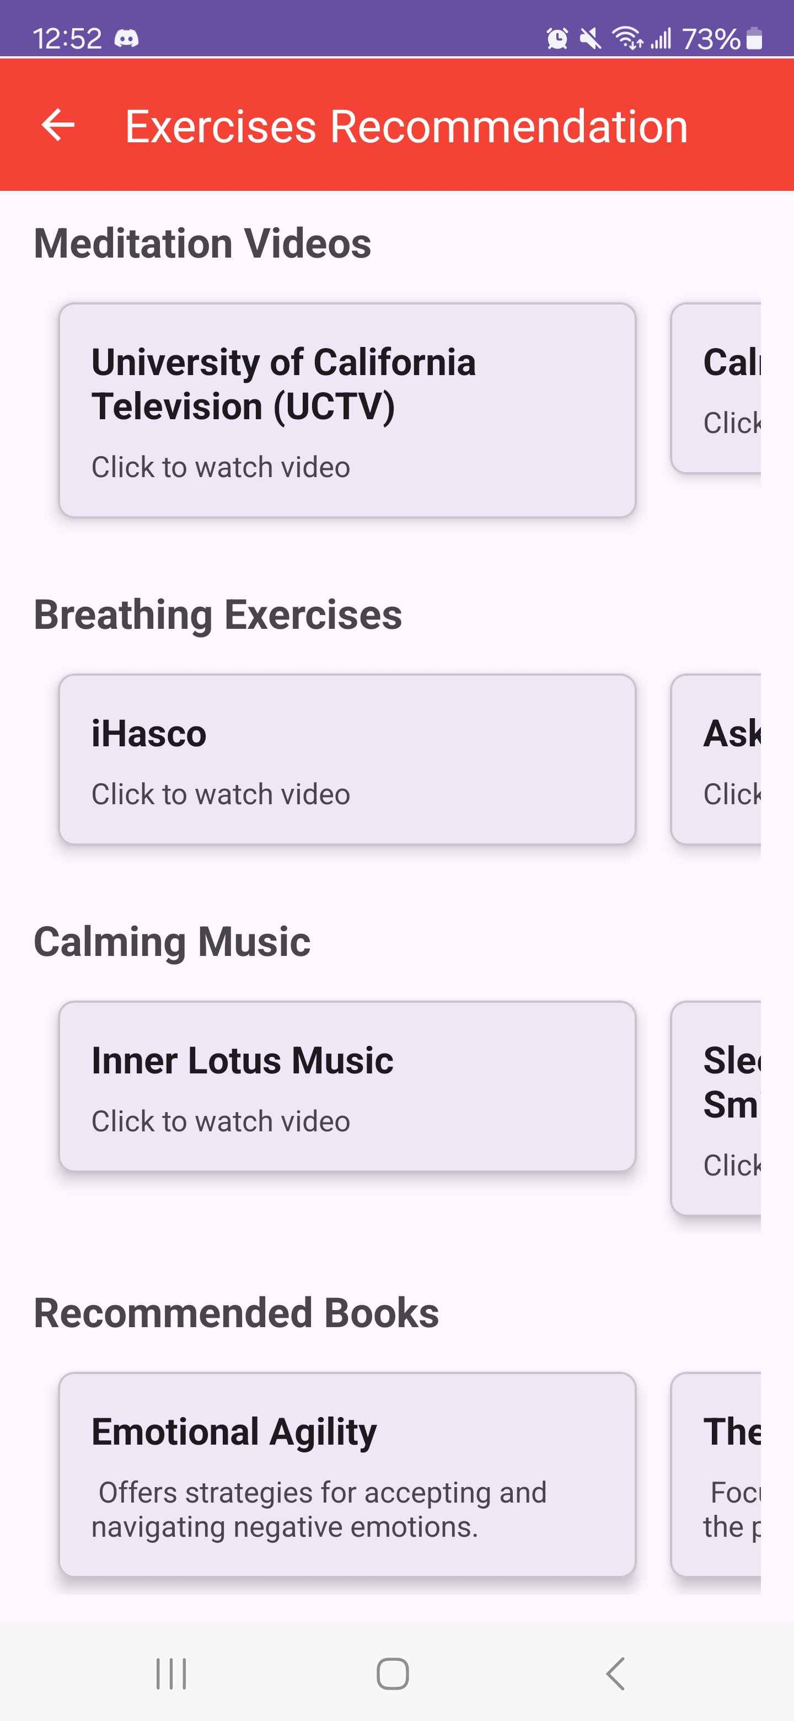

(Figure 5: Exercise Screen)

The view history interface will allow users to view their past mental states and status to keep track of their history(Figure 6)

(Figure 6: History Screen)

The settings interface will allow users to change personal information, change password, set notification times, show user information, and the option to delete one’s account.(Figure 7)

(Figure 7: Settings Screen)

If a provider has logged in, they will be taken to the providers main interface which includes a add/remove client, view client history, settings, sign out. (Figure 8)

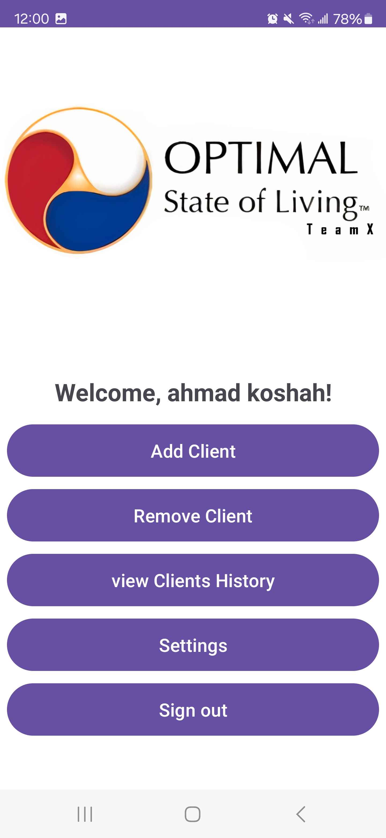

(Figure 8: Provider Home Screen)

The provider add interface will allow providers to add clients (Figure 9)

(Figure 9: Add Clients Screen)

The Remove interface will allow providers to view their current clients along with the ability to remove them(Figure 10)



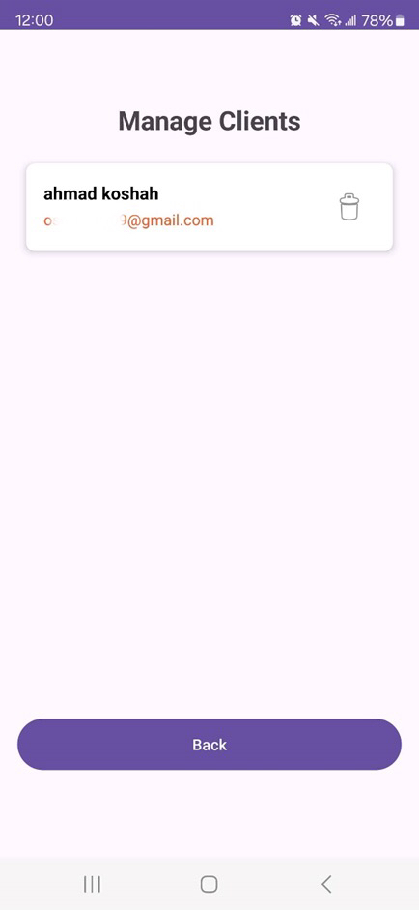



(Figure 10: Remove Client Screen)

The provider view client history will list current clients along with showing their last recorder assessment.(figure 11)

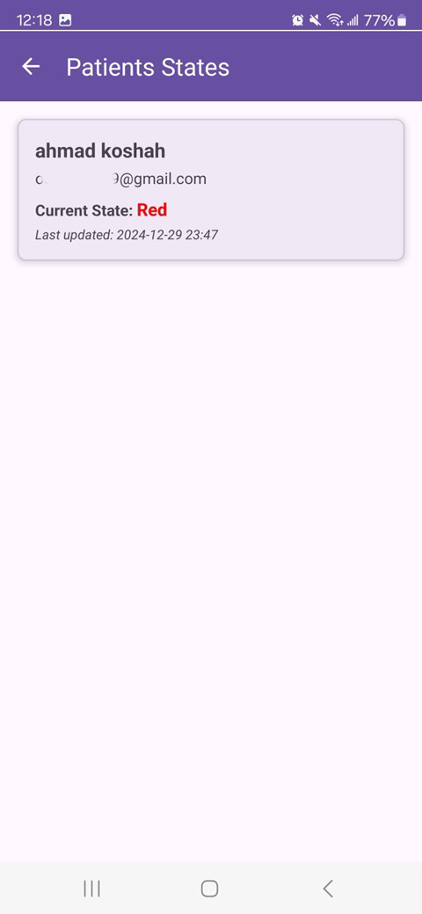

(Figure 11: view client history)

The provider settings interface is similar to the general user settings minus the set notifications feature.

## 3.3 Performance requirements

The Firebase Web server must update user information in real time as to provide providers up to date information, as well as to update recommended exercises provided to general users. Depending on their updated status or on updated data provided by Amy Wheeler, content recommended to users will change, thus real time updates are important.

## 3.4 Design constraints

Mobile apps must be connected to the internet in order to access database and retrieve user information. Without internet access application will not be able to retrieve data required to function properly.

## 3.5 Software system attributes

### 3.5.1 Reliability

Measures will be taken to ensure the reliability of the application and that user data is secure. This means ensuring that only those who are authorized to view users information will be able to do so.

### 3.5.2 Maintainability

Software will be sufficiently documented such that the application will be easy to maintain and modify. Future features which could be implemented will be kept in mind, thus development will be very detailed and allow for future modification which clients have expressed they might like to include.

### 3.5.3 Portability

Current Android app cannot be ported to another language as this time.

Signature: TeamX

Date: 12/29/2024